Construction of Annotated Parse Tree

AIM
To write a C program to construct an annotated parse tree for the given grammar and evaluate the value of an arithmetic expression.
Grammar:
- E → E + T
- E → T
- T → num

ALGORITHM
- Start the program.
- Read the arithmetic expression from the user.
- Parse the expression using the functions parseE() and parseT().
- Create tree nodes for E, T and num.
- Evaluate the values of the expressions.
- Construct the annotated parse tree using the evaluated values.
- Display the annotated parse tree.
- Print the final evaluated value.
- Stop the program.

PSEUDOCODE
START
Read arithmetic expression
Initialize pointer to expression

FUNCTION parseT()
Read number
Create num node
Create T node with value
RETURN T node
END FUNCTION

FUNCTION parseE()
Create left node using parseT()

WHILE '+' is found
Read next T node
Add left and right values
Create E node
END WHILE

RETURN E node
END FUNCTION

Create root using parseE()
Display annotated parse tree
Print final evaluated value
STOP

PROGRAM

#include <stdio.h>
#include <stdlib.h>
#include <ctype.h>

typedef struct Node {
char name[10];
int val;
struct Node *left, *right;
} Node;

Node* createNode(char *name, int val,
Node *left, Node *right) {
Node *n = (Node*)malloc(sizeof(Node));

sprintf(n->name, "%s", name);
n->val = val;
n->left = left;
n->right = right;

return n;
}

Node* parseT(char **s) {
int num = 0;

while (isdigit(**s)) {
num = num * 10 + (**s - '0');
(*s)++;
}

return createNode("T", num,
createNode("num", num, NULL, NULL),
NULL);
}

Node* parseE(char **s) {
Node *left = parseT(s);

while (**s == '+' || **s == ' ') {
if (**s == ' ') {
(*s)++;
continue;
}

(*s)++;

while (**s == ' ')
(*s)++;

Node *right = parseT(s);

int result = left->val + right->val;

left = createNode("E", result, left, right);
}

return left;
}

void display(Node *root, int level) {
if (root == NULL)
return;

for (int i = 0; i < level; i++)
printf(" ");

printf("%s = %d\n", root->name, root->val);

display(root->left, level + 1);
display(root->right, level + 1);
}

int main() {
char expression[100];
char *s;

printf("Enter arithmetic expression: ");
fgets(expression, sizeof(expression), stdin);

s = expression;

Node *root = parseE(&s);

printf("\nAnnotated Parse Tree:\n");
display(root, 0);

printf("\nFinal Evaluated Value = %d\n", root->val);

return 0;
}

INPUT

10+20+30

OUTPUT
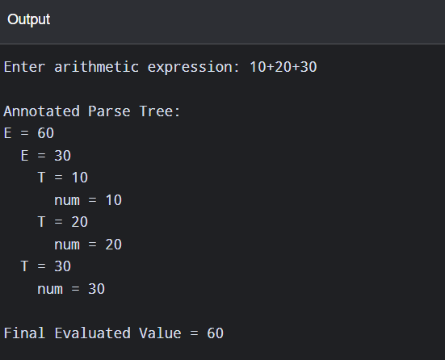

RESULT
Thus, the C program to construct an annotated parse tree and evaluate the arithmetic expression was successfully executed

